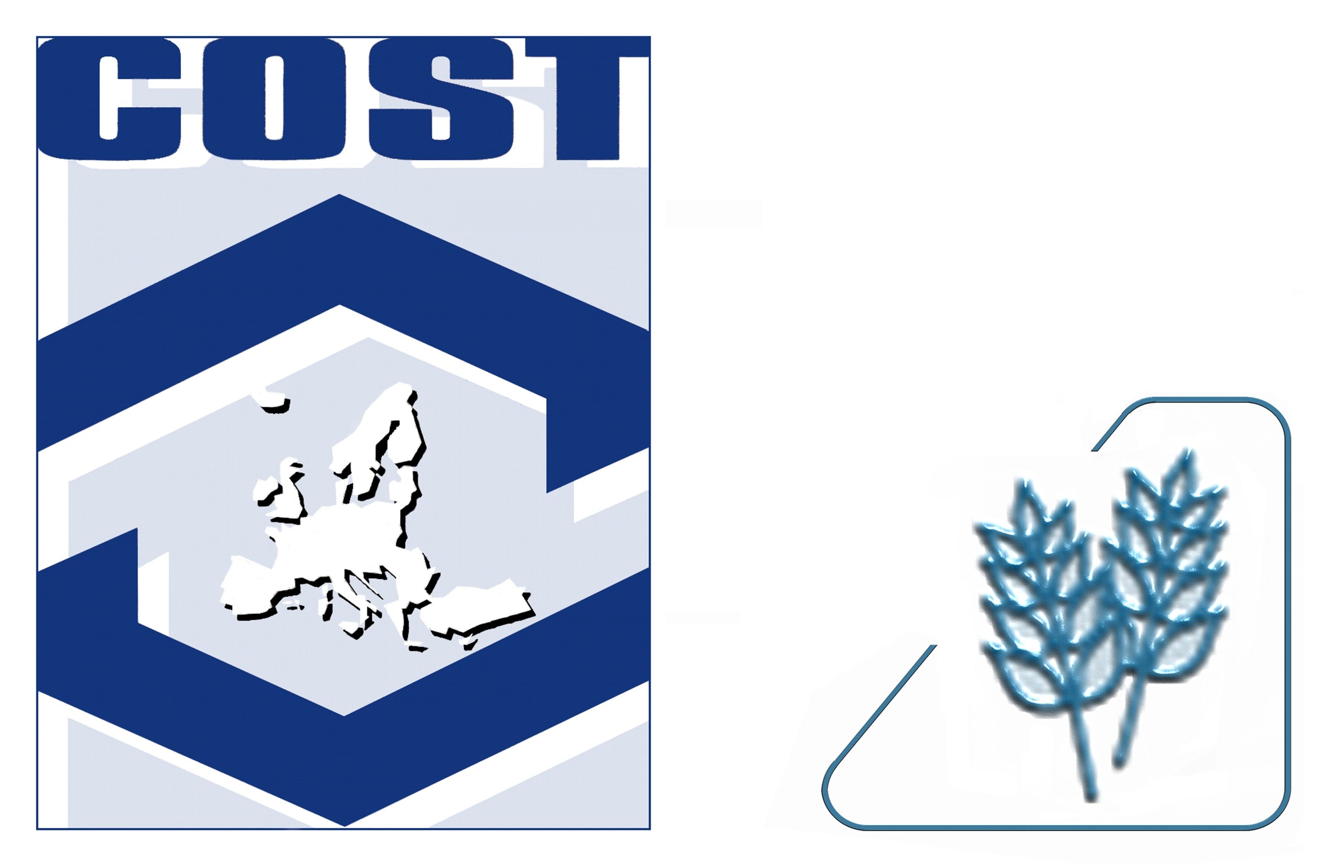
Preliminary Programme
Conference and WG meetings
COST Action FA0904
“Eco-sustainable food packaging based on polymer nanomaterials”
28-29th June 2010

Venue: “P.Poni” Institute of Macromolecular Chemistry, Conference Hall, 41A Grigore Ghica Voda Alley, Ro 700487 Iasi, Romania,
Tel.: +40 232 217454 Fax: +40 232 211299 http://www.icmpp.ro

Monday, June 28th, 2010

8:00-9:00 | Registration
9:00-9:40 | Opening of the meeting  Adoption of the agenda  Local information  Clara Silvestre: COST Action FA0904 Chair,  Bogdan Simionescu: PPIMC Director  Rimantas Venskutonis: COST Action Rapporteur  Cornelia Vasile: CONFERENCE Chair
9:40-10:40  10:40-11:00 | Chairperson: Cornelia Vasile  Plenary lecture: Leader WG1  Towards new safe nanomaterials for food packaging  Vähä-Nissi Mika  Plenary lecture: Leader WG2  Active NanoBioComposites of Interest in Food Packaging Applications  LAGARON Jose M., BUSOLO Maria, SANCHEZ-GARCIA Maria D., lOpez-rubio Amparo, OCIO Maria J.  Coffe Break
11:00-12:45 | Working Group1  Chairperson Vähä-Nissi Mika  The preparation and exploitation of safe nanoparticles in polymer films for food packaging.  MitchelL Geoffrey R.. DAVIS J. Fred .  The role of bacterial bioflm and oxidizing enzymes in biodegradation of plastics  Sivan Alex, Santo Mira, GILAN-OR, Irit, YANIV Moshe  Nano- and microsized starch derivatives and their applications  RUTKAITE Ramune, Bendoraitiene Joana, klimaviciute Rima^{c}, Zemaitaitis Algirdas  Working Group 2  Chairperson : Jose Maria LAGARON CABELLO  Influence of organically modified montmorillonite on processing and mechanical properties of polycarbonate  KOZLOWSKI Marek, FRACKOWIAK Stanislaw  New systems based on ldpe/chitosan/mmt for active packaging  Darie Raluca Nicoleta, Cheaburu Catalina Natalia, Vasile Cornelia  Bio-hybrid nanocomposite packaging materials from polysaccharides and nanoclay.  Vartiainen Jari, tuominen Mikko, NÄTTINEN Kalle, TAMMELIN Tekla, PERE Jaakko, TAPPER Unto, HARLIN Ali
12:45 13:50  13.50-14.30 | Lunch  Institute Visit
14:30-15:30 | Visit to Botanical Garden
15:30-17:30 | Poster Session  - Biocidal starch derivatives. Zemaitaitis Algirdas, SARKINAS Antanas, Bendoraitiene Joana, klimaviciute Rima  - Potential use of the lignin in polymer films for food packaging applications, CAZACU Georgeta, DARIE Raluca Nicoleta, VASILE Cornelia  - Sustainability and life cycle assessment for food packaging applying polymer nanomaterials. Pihkola Hanna, Hohenthal Catharina, VÄHÄ-NISSI Mika  - Development of bioactive packaging - Eureka project E! 4952 biopackaging CONSTANTINESCU Doina, Avadanei Lidia.  - Film based on ethylene-vinyl acetate copolymer/montmorillonites nanocomposites for development of the active packaging materials Baican Mihaela, Oprea Ana Maria, Crivoi Florina, Vasile Cornelia.  - Chitosan/ polyvinyl alcohol blends for active food packaging. Parpariţă Elena, Cheaburu Catalina Natalia, Vasile Cornelia  - Isolation of Bacillus megaterium strains for PHA production Stoica irina, Bahrim Gabriela  - Investigation of properties of plasma polymers deposited by rf magnetron sputtering of nylon Artemenko A., Choukourov A., Gordeev I., Kousal J., Kylian O., Polonskyi O., Slavinska D., Biederman H.  - Shear-Induced Crystallization of Isotactic Polypropylene(iPP) based Nanocomposites with Montmorillonite (MMT), Duraccio Donatella, Pezzuto Marilena, Silvestre Clara, Cimmino Sossio, Mitchell R. Geoffrey  - Characterization of mLLDPE/LDPE blends obtained by blow-molding Duraccio Donatella, Mauriello Amalia, Pezzuto Marilena, Silvestre Clara, Cimmino Sossio  - Silica/Acrylate And Silica/Epoxy Hybrid Materials Through The Sol Gel Method. Silvestri B., Costantini A., Luciani G., Tescione F., Branda F. Silvestri Brigida  - Characterizing PSI-co-PEG block copolymer Nistor Manuela. Tatiana, Nita Loredana Elena, Chiriac Aurica. P., Cimmino Sossio., Silvestre Clara., Duraccio Donatella., Vasile Cornelia.  - Microbial aspects of Eco-sustainable food packaging Nielsen Per Væggemose  - Tailoring of polymeric materials at the nanoscale for sustainable packaging PLUMMER Christopher, YVES Leterrier, JAN-ANDERS E Månson
19:00-22:00 | Joint Dinner

Tuesday, June 29th, 2010

9:00-10:00 | Chairperson Valeria Harabagiu  Plenary lecture: Leader WG 3  Current state of knowledge in regard to interaction of PNFP with packaged food products  Chaudhry Qasim  Plenary lecture: Leader WG4 Some Environmental Aspects of Polymers, Old and New  G. HUNT
10.00-11:15 | Working Group 3 and 4  Chairperson: Chaudhry QASIM  Carbon based nanomaterials suitable for detection of bacteria and biofilms on the surface of Plastic films  Moore Edward, Blau J Werner, BABU Ramesh  Biodegradable nanocomposites for packaging and protection of consumer goods.  Merijs Meri Remo, Zicans Janis, SVINKA Visvaldist  Zinc Oxide in Polymeric Matrices: Synthesis of the Sub-Micronic Powders, Processing and Anti-microbial Activity of the Composites  DeXpert-ghys jeannette, DROVAL Guillaume, VERELST Marc, ROSSIGNOL Cécile  Electrospun EVOH fibres reinforced with bacterial cellulose nanowhiskers with potential in food packaging applications  Martinez-sanz Marta, olssoN Richard, lOpez-rubio Amparª , LAGARON Jose Maria  NanoPack – a Danish research project on bio-nanocomposites for meat packaging Plackett David
11:15 11:40 | Coffee break
11:40- 12:00 | Napolynet European Open Laboratory: Experimental Mechanics of Micro & Nanomaterials  KOTSILKOVA Rumiana
12:00- 13:30 | Parallel Meetings of the 4 Working Groups
13:30-14:45 | Lunch
14:45 -16:30 | Round table dedicated to Industry  Moderators: Rumiana Kotsilkova and Doina Constantinescu
16:30-17:30 | WG Meeting Reports by WG leaders
17:30– 17:45 | Conclusions  Clara Silvestre

